#9. Filtering: removed individuals with call rate <50%, loci call rate <80%, 1017 SNPs

1. Progeny population
2. Parent population
3. Overall sample

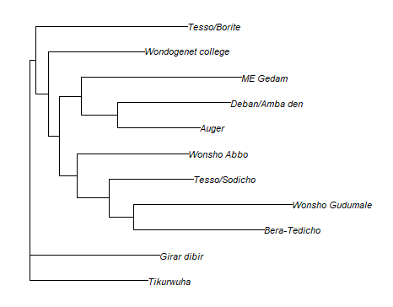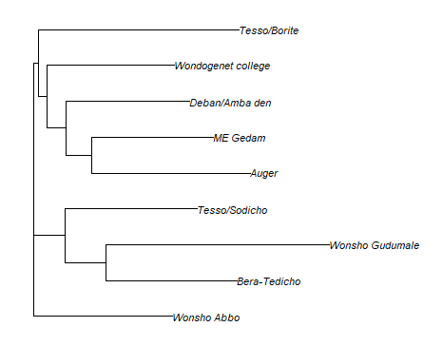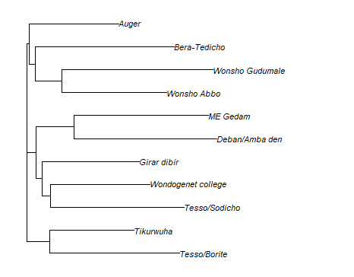

Sidama

Sidama

Nursery population

Gurage

#8. Filtering: removed individuals with call rate <50%, loci call rate <90%, 157 SNPs

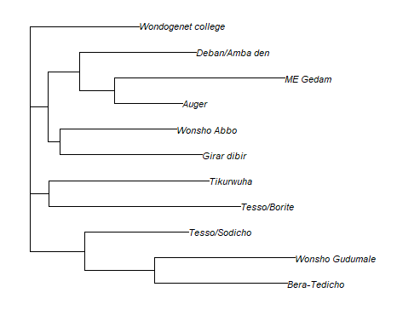 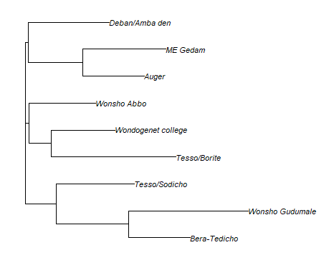 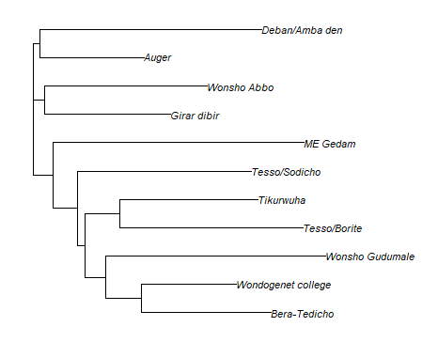

#1.1. Filtering: removed individuals with call rate <50%, loci call rate <70%, 2745 SNPs

